Learn about programs and services available to students with disabilities.
- Job Training
- Post-Secondary Education
- Independent or Assisted Living
- Recreation and Social Activities
- Community Resources
- Financial Planning Advice
- Vocational Rehabilitation & much more!
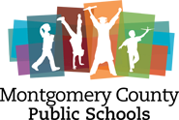
You are invited to attend a
TRANSITION FAIR
Presented by MCPS Special Education
& the Parent Resource Center
When: Thursday, April 11th 2019
Time: 4-6 p.m. Come and go as you please!
Where: Christiansburg High School Cafeteria
100 Independence Blvd. Christiansburg

This event is free. No registration is needed to attend.
All students, parents, guardians and
community members are invited to attend.

Come visit for a chance to win door prizes!

For questions please contact dwells@mcps.org or cassiefitzgerald@mcps.org

