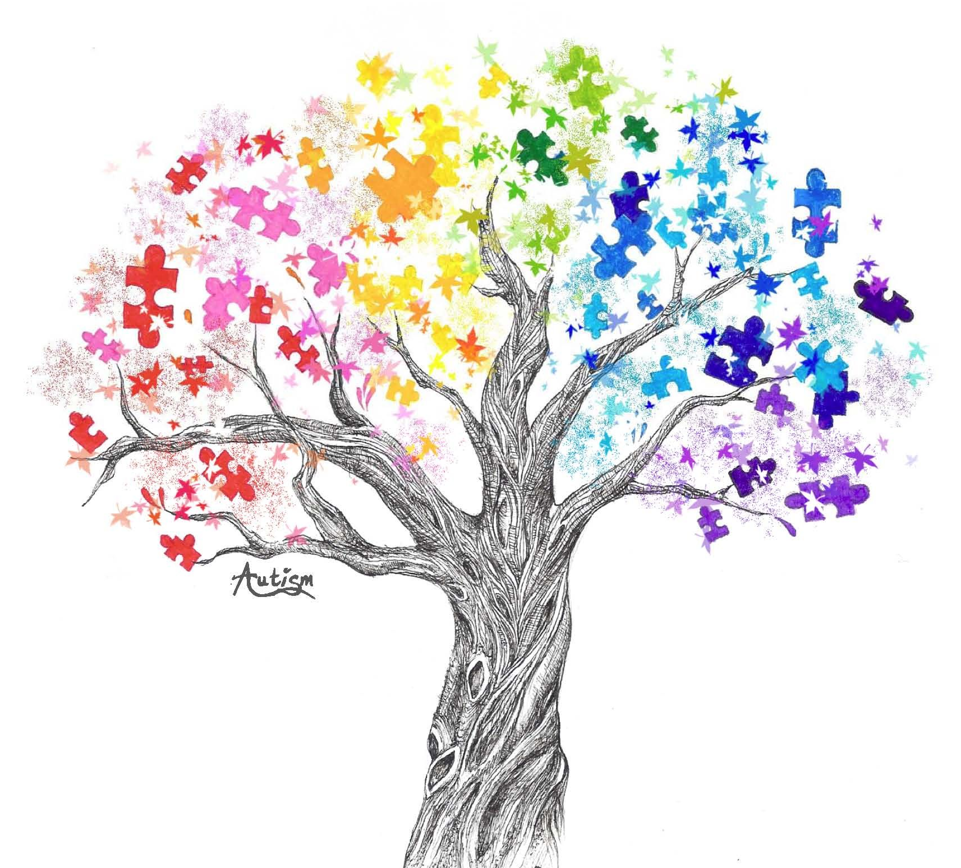  Mcps special education and PRC presents:  grow your awareness  Autism Workshop  (Make and take workshop centered around evidence-based practices for students with Autism)  March 11, 2019  (6:00-7:30)  This workshop is free. Parents, Guardians, Educators, Service Providers and Community Members are welcome.  Refreshments will be provided.  Parent Resource Center Contact: cassiefitzgerald@mcps.org | Time: 6- 7:30 P.M.  ────  Location: Main Level of School Board Office- Conf. Room A  750 Imperial St. Christiansburg  540.382.5114  Come join us for an “Au-mazing” workshop filled with exciting information! Learn about evidence-based practices while creating your own take-away of token boards, visual supports, social stories and web-based information. Receive autism friendly resources from the PRC and much more!  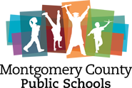  To Register:  https://goo.gl/forms/y5S03Oms2FDtx9n82

